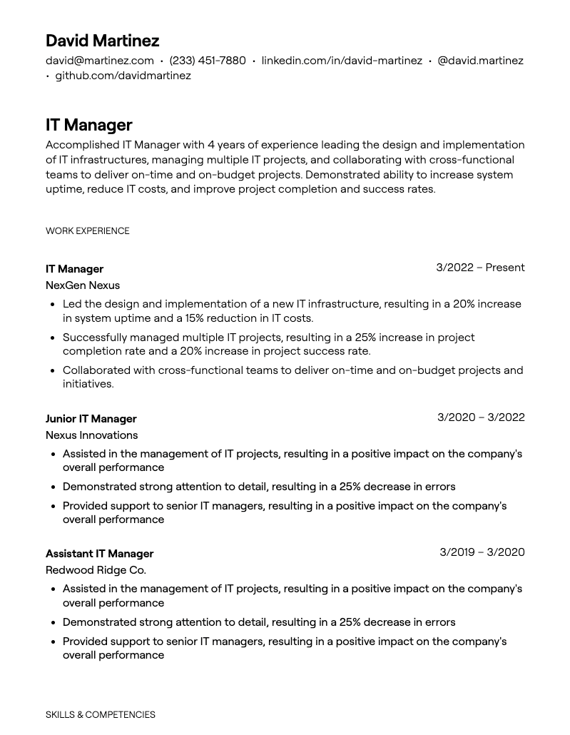
David Martinez
david@martinez.com (233) 451-7880 linkedin.com/in/david-martinez @david.martinez .github.com/davidmartinez
IT Manager
Accomplished IT Manager with 4 years of experience leading the design and implementation of IT infrastructures, managing multiple IT projects, and collaborating with cross-functional teams to deliver on-time and on-budget projects. Demonstrated ability to increase system uptime, reduce IT costs, and improve project completion and success rates.
WORK EXPERIENCE
IT Manager
NexGen Nexus
3/2022 Present
• Led the design and implementation of a new IT infrastructure, resulting in a 20% increase in system uptime and a 15% reduction in IT costs.
Successfully managed multiple IT projects, resulting in a 25% increase in project completion rate and a 20% increase in project success rate.
• Collaborated with cross-functional teams to deliver on-time and on-budget projects and initiatives.
Junior IT Manager
Nexus Innovations
3/2020 - 3/2022
• Assisted in the management of IT projects, resulting in a positive impact on the company's overall performance
• Demonstrated strong attention to detail, resulting in a 25% decrease in errors
• Provided support to senior IT managers, resulting in a positive impact on the company's overall performance
Assistant IT Manager
Redwood Ridge Co.
3/2019-3/2020
• Assisted in the management of IT projects, resulting in a positive impact on the company's overall performance
• Demonstrated strong attention to detail, resulting in a 25% decrease in errors
• Provided support to senior IT managers, resulting in a positive impact on the company's overall performance
SKILLS & COMPETENCIES

